1.29

Fut expire on Jan 30 (tomorrow).

Build pos/roll.

5 futs remaining on expiring future.

Cut pos for a bit. Need to do intraday trading.

On Expiry: make sure

1. Expiring fut wtd pnl needs to be correct

1018

Positioning on alcohol bit heavy. Don’t have extra capital to trade intraday for stocks.

Not a good situation.

Fut position is much more comfortable.

Futs start having a big premium at 70 bps ~ 1%, it was a misjudgment of the market today.

1123

Markets crash into morning close.

1/3 position max reached on day trading. Plenty of trading today.

Trend pnl turns very negative following last thur’s crash and rebound.

Selling started about last Thursday where morning crashed.

If trading position remains negative, don’t trade for this week.

1349:

Markets start to adjust abruptly. Trend pnl is destroyed while there are no one picking up in the PM.

People start to cut position here.

January recap:

Started rallying aggressively without allowing for any correction, straight up for 10+ session. There was no place to add position. As soon as markets slow down and you start going in, it would be already correcting. Under this framework, you have to fight for position when it just starts moving.

Markets are volatile in the short term but long term it is the fundamentals that matter.

Keep long term position.

Position adding was late and it already started correcting once you add position. This means in the long term you need position on if you trade trend pnl.

1.30

Currently hold about 4mm delta on futs. During confusion period sell down to half position, (about 1.5mm) with a profit. PM increase delta to full.

PD trading rationale:

1. Futures reflect future price movements
2. Futures are subject to day trading and more intensified emotions
3. On T, futures usually sell into discount to reflect global market weakness, because markets are correlated
4. Short term day traders who aggressively sold need to cover their position (provide liquidity to them)

Lunch break:

Futs closed at lows. PM exposure about 5.8m.

Close action:

Futs: bring down to about half position. ( -> 1.5mm delta)

Stock: no need to touch.

**Close:**

There was no pmcl.

Holding 6mm delta.

The rise since year beginning was a bit much. Tuesday rebound even doesn’t have strength here.

Stock cutting: end of march (2 months after)

Future cutting: natural expiry.

Monitoring changes: Open and close.

Trading: Halt.

Reason: Rally was too aggressive, which broke the rhythm of the market. (15 ups in a row)

**Going forward:**

1. Focus on trading at close for a position adjustment.
2. PD trading.
3. Do not trade in AM.

Recapping period of losses:

May loss: 5-4 to 5-8 (-111k loss) (Thur, Fri, Mon) (Xiong An loss)

Aug loss: 8-1 to 8-11 (-102k loss)

Nov loss: 11-22 to 11-27 (-120k loss)

Jan Loss: 1-29 to 1-30 (-96k loss)

Correction usually lasts 3 days to 2 weeks.

You would lose about 100k or so. In hindsight these were spots to pick up position

Losses come quickly and it is important to wait until market stabilizes before you add additional positions.

Position is usually cut and ptf recovers much more slowly than index.

Ideally, you should avoid the losses and add position after, but it is not feasible, so you should keep the same position regardless of market conditions.

You want to make sure your position size doesn't reduce after a fall-out.

If you trade the same delta both at the peak and trough, the upward slope will make more than the downward slope, even if the index only fluctuates, it would take more percentage return to reach the same level from which it dropped.

If you cut position too early, that would be the opposite of what you should do. The pnl is a sunk cost. Position should increase on the way down.

Other:

Hainan education is really bad – I don't think you should stay here for the long term.

Investment is a long term endeavor. Markets are hard to time. Hold things long term, with periodic 调仓. Make sure you have position all the time. Focus on firms with solid earnings and products, when you buy something prepare to hold for years. When you bought Tencent at 200 and sold at 190, you didn’t know it would rise to 400.

Looking at the market through its meaningless fluctuation is a waste of time, unless you are providing clients with quotes.

Large committed positions in good assets are more effortless and effective than changing positions every day. You need to give positions time.

Invest in solid earnings, regardless of economic situation.

Stop doing random trading. Form a well-rounded portfolio and hold for 1 year.

Change focus: expand your views and horizons.

Information, trend, newest stuff, creativity, imagination, research into newest areas.

Buy the best companies. Hold long term.

Margin account: do some close trading.

1.31

Change swimming time to AM from 10 to 11.

PM: Skate.

Positioning: I was using light positioning and added position when I saw markets were doing while but guess what it was the top. Addition like this will invariably result in buying high and selling low. Two days cost 3.5% of ptf and ytd pnl is down. This show you cannot time the market. It is better to use same positioning everywhere regardless of index level.

When you add position when markets are going down and it doesn’t rebound, you are stuck there like a duck unable to trade for the whole month.

You don’t benefit from the market moves.

For stock ptf, you should invest in good sectors and hold full position. Don’t touch the stock ptf. **Use margin ptf to do some side trading.**

Holding full position and trading less forces you to think about choosing the correct stocks and holding them long term.

Handling crashes:

1. Let the first crash go, no trading on first drop.
2. Start Drop+1 PM. Soft accumulation.
3. If rebound, sell. If no rebound, there will be a rebound in the next few days.

Margin position:

1. Trade drop T+1 PM. (PM start + close)
2. Increase exposure to key sectors.
3. Increase long term position when index dropping -> keeping constant exposure.

2.1 Thurs

Markets seeking direction here.

Transferred assets into margin account.

After mon-tues crash, this level I consider to be comfortable to be full position.

Hold position and use margin to do close trading.

**Need bank positioning:**

Reason:

Out of 20 top ytd sharpe stocks, 6 are banks, 5 are property.

招商蛇口 PE too high.

Banks: add position. PE too cheap.

ICBC PE is 9. Still tradable. Nobody wants to buy banks yet – good.

Do close trading on highest sharpe stocks.

Stock university development:

1. Recent new high (a lot of interest in new high stocks) (pick 10 stocks with recent new highs)
2. Two real down candles (Always pass the first down candle)
3. Start accumulation
4. Use 5 candle rule: bear market enter when 5 consecutive candles have 3 plus candles. Stop trading when there are less than 3 up candles within 5 candles.
5. Alternative stop trading: 3 day loss, stop week trading. 2 week loss. Stop month trading. 2 month down. Stop year trading.
6. Loss cutting:

More

1. Pick 10 stocks that achieved new highs most recently (New High Universe, rank by YTD sharpe)
2. Pass the first drop (best if pm very negative)
3. Second day: focus on accumulate at the lowest of PM
4. If second day pm rebounds: sell all next AM
5. If second day closes at lows: Sell half in AM, half at close on the third day

This takes advantages of there are rarely more than 2 down days for strong stocks and strong stocks always break highs.

FailSafe: keep holding long term.

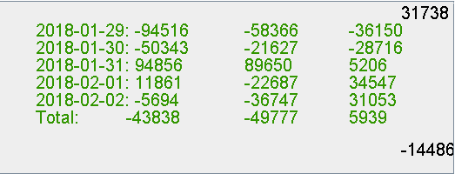

Week review:

Markets wash.

Going forward

1. Stay away from first negative candle
2. Trade pm and close
3. Liquidate next day for margin positions
4. Holding long term position under 2-2-2 principle.

Research

1. Weak stocks have no more than 3 plus candles within 5 days. Determine weakness.
2. Strong stocks have no more than 3 down candles within 5 days. Determine strength.
3. Aim at recent new highs stocks, rank by ytd sharpe. Enter on PM on decent positioning.
4. Stay away AM trading. (on both the futures and the stocks, cost a lot in the futures this week)

Trade pnl on the futures is -2.4k USD on Jan 29 morning trades and all subsequent trades were wiping its ass. Make sure you don’t get slaughtered on trend pnl at max position. Even 8 lots caused major damage. Keep constant trend position if you want exposure. Your issue was trend position was too small before and now its ballooned up.

2.3

US crashed overnight -2.3%.

Hold XINA50 position until the end of the month as spring usually performs well. (Feb+Mar+Apr) through the volatility.

2.4

Research

Quarterly:



First quarter is the best returner at 4%.

Second and fourth quarter return 3%.

Third quarter return flat (summer period, July – Sep, lots of vol). Summer is quiet in usual and china tends to go down. Time to hold light position and travel.

**Monthly:**

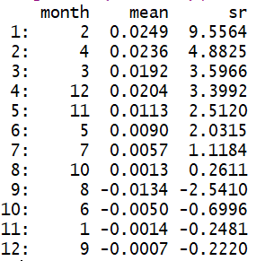

Best months for trading.

Comment: past January which is generally a lot of 解禁 stocks, market enters into rally mode for three straight months.

**3 Month Roll:**

Best 3 month (quarter) roll:

(2,3,4 roll is good, keep decent size position here). Worst 3 month continuation is 6,7,8. Anything that contains 8 will lose money. Aug should clear position.

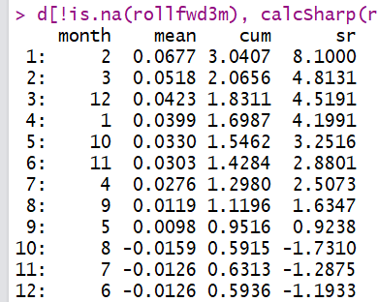

2 Month roll:

Best two months roll: feb+march.

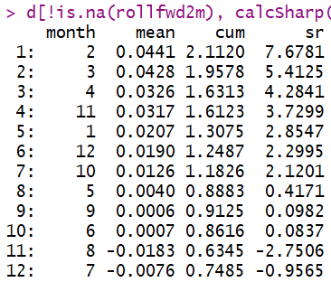

4 month roll:

